AN AWARD WINNER INTERNATIONAL ORGANIZATION
a Im
PROMOTING EXCELLENCE IN DENTAL EDUCATION
Over 7000 Members Strong
Presents
A Must attend seminar for you and your staff
INCORPORATING DENTAL LASER TECHNOLOGY
BY
DR. BRADLEY LABRECQUE,DDS
ONLINE WEBINAR

On
JUEN 2ND, 2024 (Sunday) 8:00 am till 10:00 am
(CA Board 2 hrs C.E. units)
at

(Please print in capital letters or attach your business card)
Name DR/RDH/RDA/DA Lic no
Circle one First Middle Initial Last
Address
City State Zip
Cell no ______________ Accept text message yes/no E-Mail________________________________________
ARE YOU A PDS MEMBER: YES/ NO

REGISTRATION FEE
Dentists Non-members | $50.00
Members | $40.00
Hygienist/R.D.A. Non-members | $40.00
Members | $35.00
FOR REGISTRATION
CALL TOLL FREE 1-866-422-5573 (1-866-4-CALL-PDS) OR 909-933-9076
TO REGISTER ONLINE VISIT US ON WWW PDSOCIETY. COM

Make check payable to

Dr. R. Salwan
President
PDS
124 EAST F STREET SUITE #8 ONTARIO, CA 91764
Dr. D.P. Singh Nagra
Chairman

Dr. Brad Labrecque, DDS
Dr Labreque is a general dentist whose focus is
incorporating Laser Technology in the modern dental
practice. He is passionate about training dental practitioners
in the use of Dental Lasers in all clinical procedures.
Dr. Labrecque implemented lasers early in his clinical
practice being one of the first dentists in Canada. He has
taken hundreds of hours of continuing education and his
practical experience makes him a global authority on Laser
Dentistry and is sought after by dental practitioners
worldwide to train them in successful implementation of this
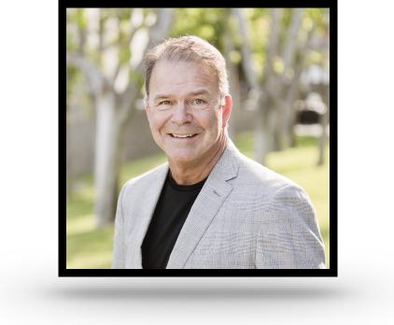
technology to improve their clinical outcomes from
the traditional dental protocols.
Since 1995 Dr. Labrecque has lectured globally on this technology in many conferences including Canada /USA/ Australia/ New Zealand /Iceland / Slovenia / Germany. This is due to his extensive knowledge in all wavelengths of dental lasers.
Dr. Labrecque maintained a general group practice at Cedar Dental Centre in Kamloops BC Canada since 1984 - 2019 where it is focused on minimally invasive dentistry.
Topics that will the covered include
- Learn how to incorporate technologies (lasers), the wide range of benefits they have in clinical dentistry, and how patients can benefit from their uses
- Learn common clinical uses for YSGG lasers, how they can address patients concerns and provide improved clinical results
- Discuss and clearly understand insurance billing, patient education and how to attract the right type of new patients with laser technology
- Learn how hygiene lasers can be used as an adjunct to scaling/ rootplaning and periodontal surgery to treat periodontal disease, as well as discuss research backing up these claims
- Learn additional laser applications for treating dentinal sensitivity, herpetic lesions, veneer removal, and peri-implantitis treatment
- Learn how YSGG lasers dramatically & predictably increase the level of success of Endodontic therapy
THIS EVENT IS SPONSORED BY BIOLASE

